**Filter exercises** on name (A-Z)

Now exercises are shown by length of the word. It should be on alphabetical order.

**Option to move exercises** within a set up and down. I want to decide which exercise in a certain set has to start.

**About menu.**

A menu where we can enter some explanation about the workout generator, how it works, how to add a printer, etc.

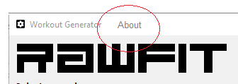

**The height** of the field must be a bit higher. It makes it easier to fill in.

